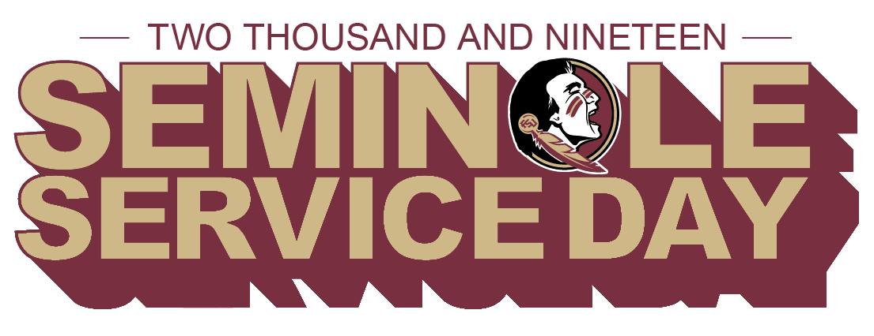

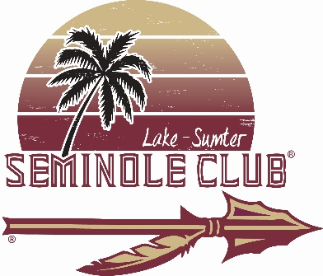 

Walking the dog…playing with kitties…helping animals find their furever home…setting posts for the paddock…assisting with admin work…All kinds of volunteer opportunities are available as the Lake-Sumter Seminole Club shares its time and talents for the Annual Seminole Service Day. Join us on Saturday, March 16th, at the Lake County Animal Shelter 28123 County Road 561 in Tavares, 10:45 AM-2:00 PM\*\* Volunteers will need to sign a liability waiver form; students under 17 will need to have an adult present. Service Day t-shirts available to the first 15 who volunteer; please email your shirt size to [lakeseminoles@gmail.com](mailto:lakeseminoles@gmail.com) by Tues, Feb 5th.

\*\*Someone from the Club will be present all day until they close at 5 PM so if you want to come later in the day, that’s fine. Also, give what time you have available if 3 hours is too long for you. We’d like to get a group picture before they open at 11.